**Adding IAM User:**

1. **Go to IAM User in aws service**

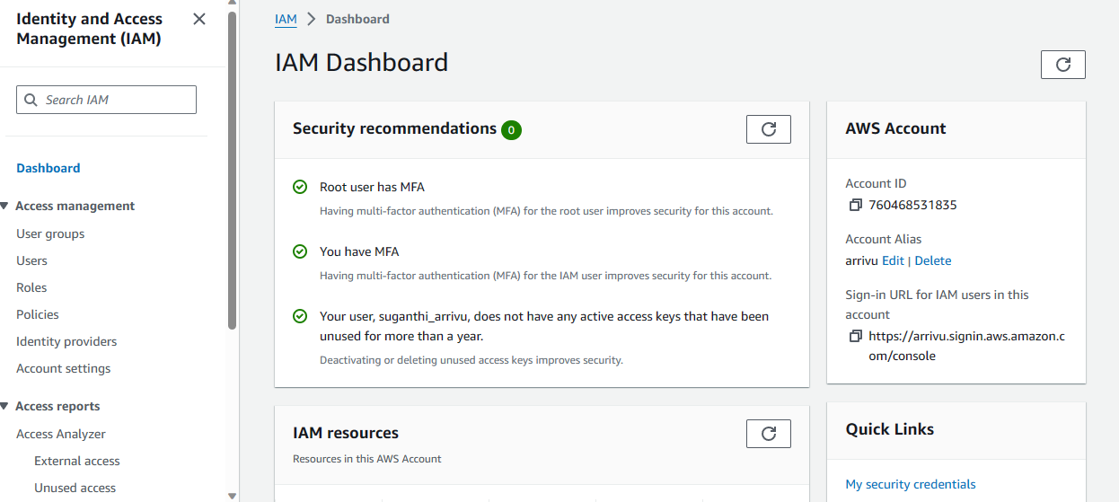

1. Click user in left panel.

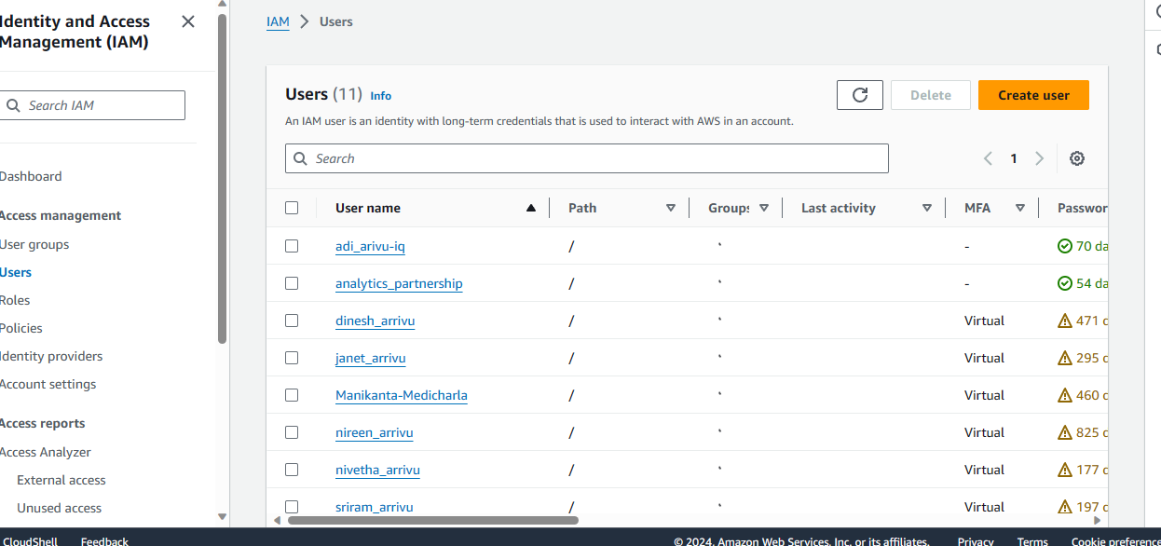

1. Click create user. Add user details and click next.

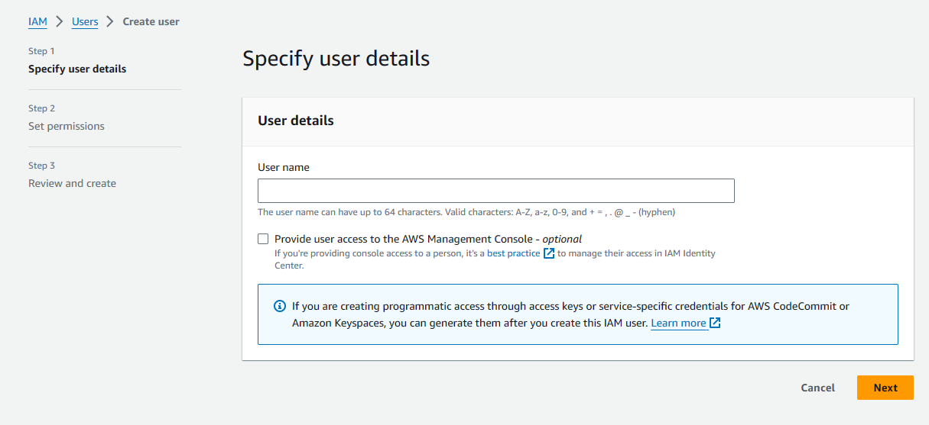

1. Select Permissions through group or we can attach the policy straightly through attach policy to user(Entry level access is best for anyone and based on the role and need give access to user) and click next.

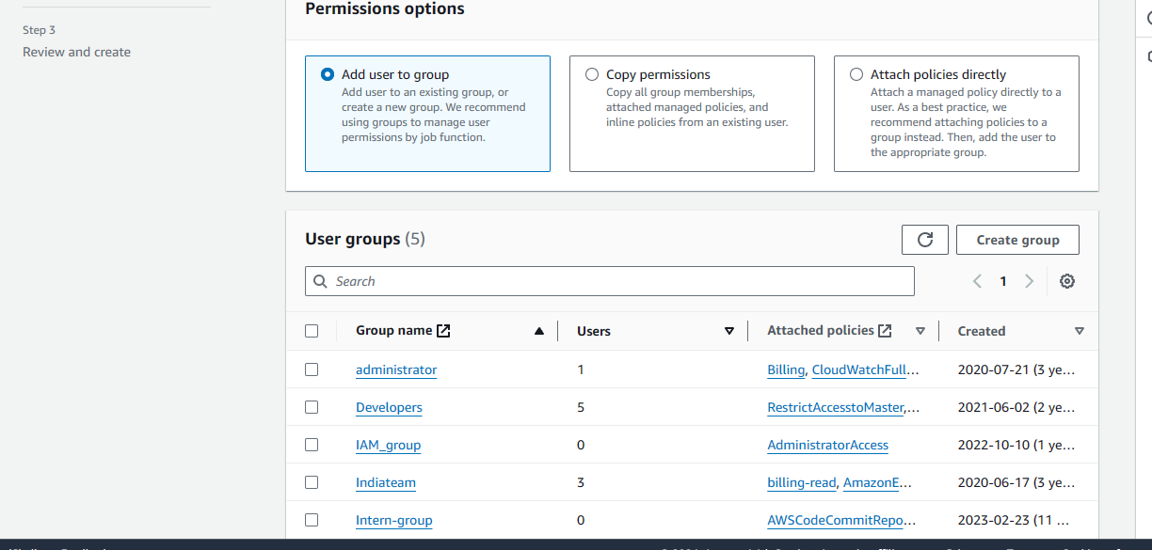

1. Review and click create.

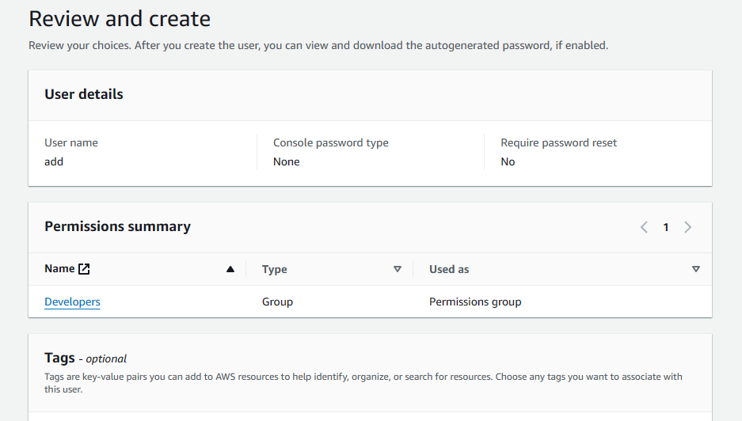

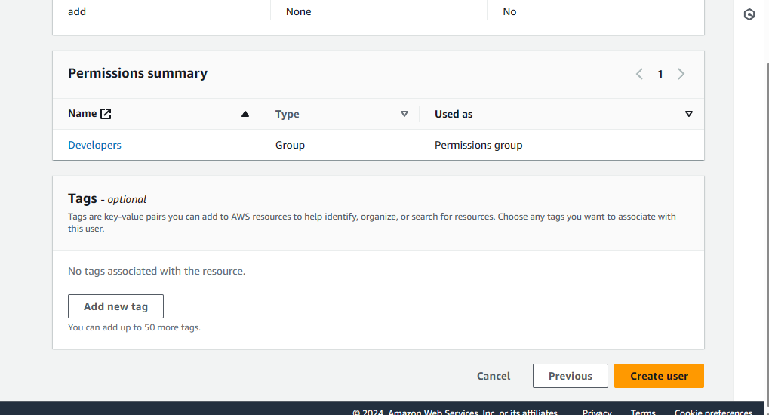

1. Now to user and click on the user name.

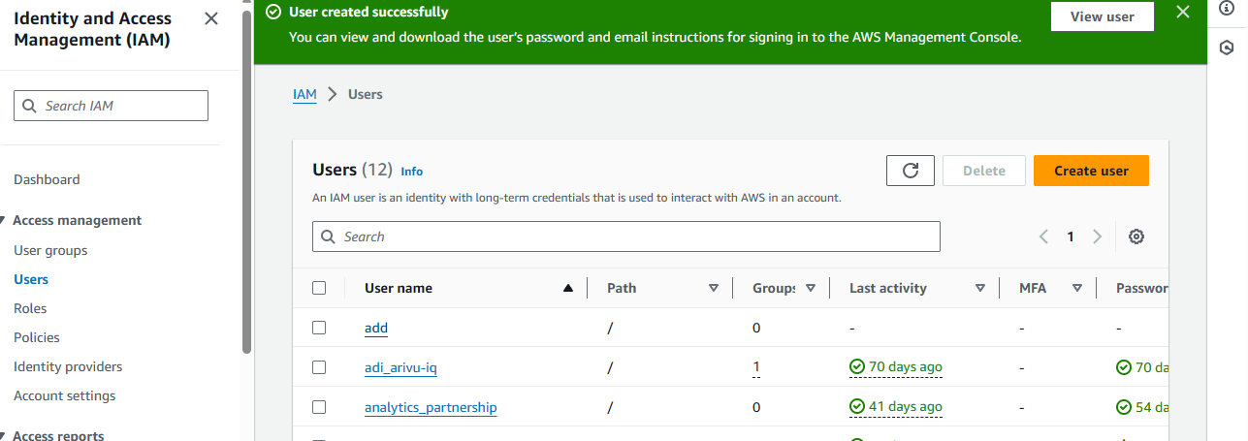

1. If you want to delete the user use delete button.
2. Goto to security credentials in 4th tab.

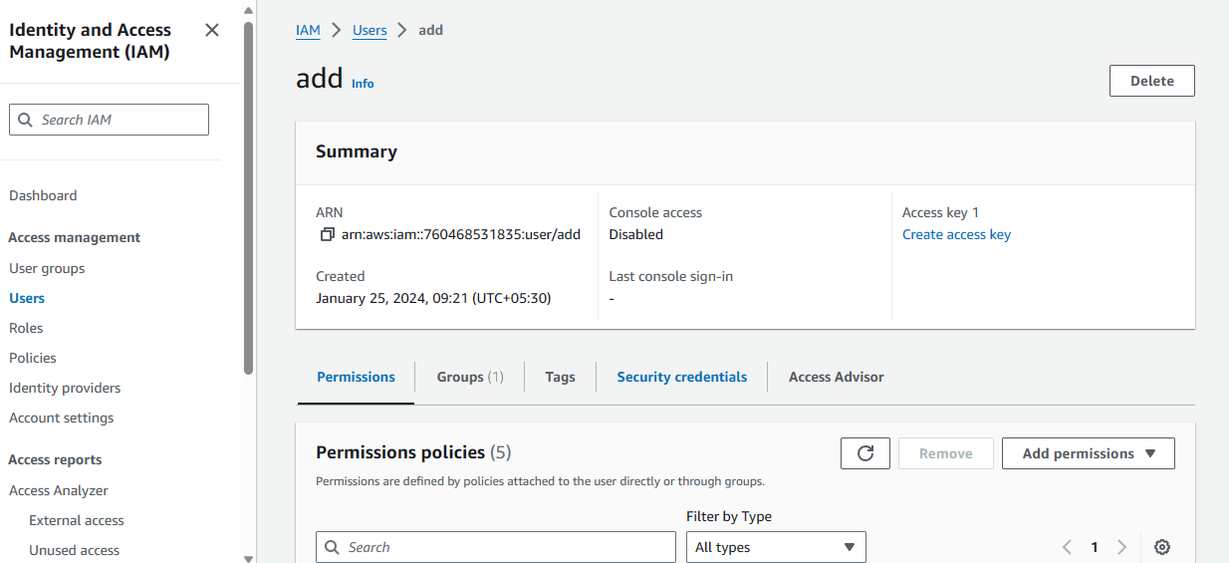

1. You will see Enable console access click on it. Select the Enable radio button.

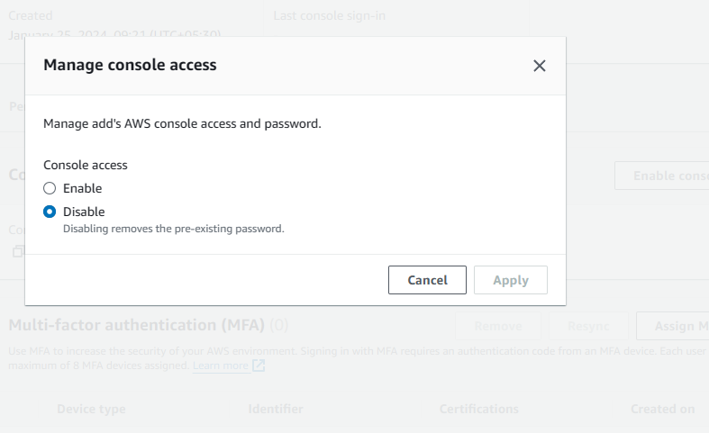

1. Click on the check box **“User must create new password at next sign-in".**

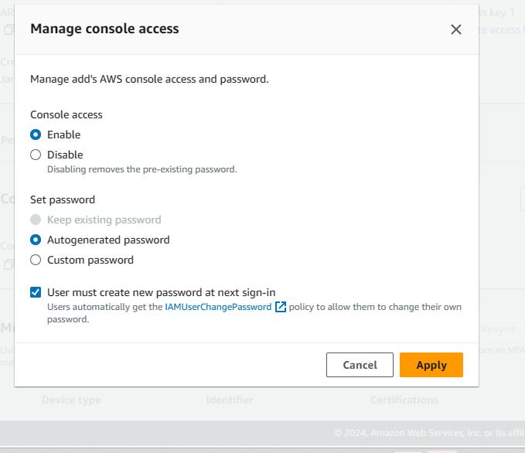

1. Click Apply.
2. This is the console username and password to login to console. While login into console for the first time you need to change the password(Download and keep it safe.)

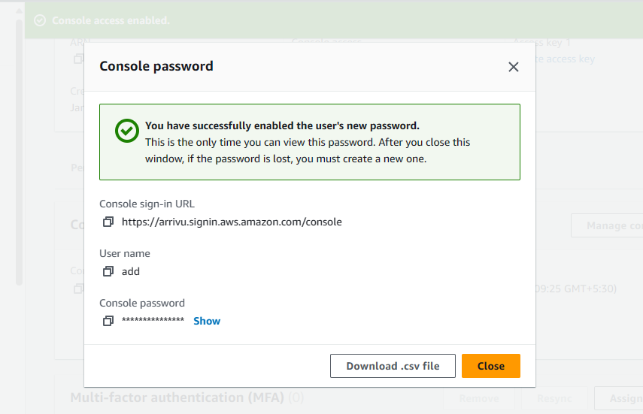

1. Below Manage console access you will Assign MFA device. So activate MFA for your account (Compulsory).

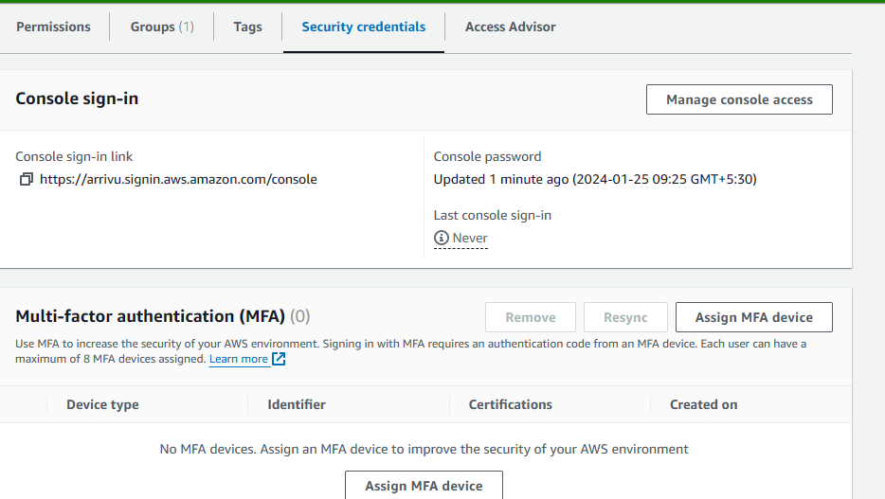

14.You will see the Access key and ssh public keys.

Ssh public key will be used for cloning the repository.

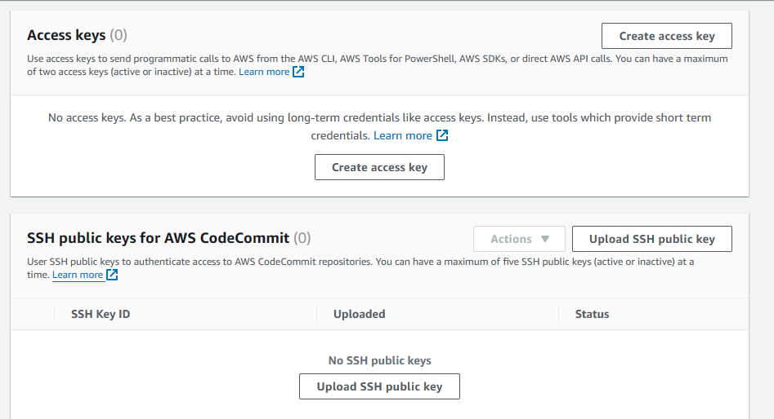

1. Next you will see Https git credentials which is used during the repositories.

